Light - 04
CLASS 10 - SCIENCE

 | Section A
1 | Define optical centre of a thin lens. | [1]
2 | Define lateral shift. | [1]
3 | Name a point inside a lens such that a ray of light passing through it goes undeviated. | [1]
4 | What is an optically denser medium? | [1]
5 | What is the S.I. unit of refractive index? | [1]
6 | How is the power of a lens related to its focal length? | [1]
7 | For the same angle of incidence of 45°, the refraction angle in three transparent media A, B and C are 25°, 30° and 35°, respectively. In which medium is the speed of light minimum and in which medium maximum? | [1]
8 | Name the lens that has:  - negative power.  - positive power. | [1]
9 | What is relative refractive index? | [1]
10 | What is magnification of lens ? | [1]
11 | If refractive indices of water and alcohol are 1.33 and 1.46 respectively, which of the two is optically denser medium? | [1]
12 | What is an optically rarer medium? | [1]
13 | What is absolute refractive index? | [1]
14 | A light ray enters from medium A to medium B as shown in the figure. 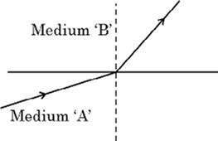  - Which one of the two media is denser w.r.t. other medium? Justify your answer.  - If the speed of light in medium A is v$​_{a}$ and in medium B is v $​_{b}$ , what is the refractive index of B with respect to A. | [1]
15 | What is the name given to change of path of light with change of medium ? | [1]
16 | Identify the device used as a spherical mirror or lens in case, when the image formed is virtual and erect in case. Object is placed between infinity and device, image formed is diminished and between focus and optical centre on the same side as that of the object. | [1]
17 | Define the term refractive index of a medium in terms of speed of light. | [1]
18 | For the same angle of incidence of 45°, the refraction angle in two transparent media P and Q is 20° and 30°, respectively. Which medium is optically denser out of P and Q and why? | [1]
19 | What is an optical medium? | [1]
20 | Name the phenomena on which the working of a lens is based. | [1]
21 | Define the refractive index of a transparent medium. What is its unit? Which has a higher refractive index glass or water? | [1]
22 | The absolute refractive index of Ruby is 1.7. Find the speed of light in Ruby. The speed of light in vacuum is 3$×$ 10 $​^{8}$ m /s. | [1]
23 | Refractive index of diamond with respect to glass is 1.6 and absolute refractive index of glass is 1.5. Find out the absolute refractive index of a diamond. | [1]
24 | What happens to the power and focal length of a lens when it is dipped in water? | [1]
25 | - A ray of light starting from diamond is incident on the interface separating diamond and water. Draw a labelled ray diagram to show the refraction of light in this case.  - Absolute refractive indices of diamond and water are 2.42 and 1.33 respectively. Find the value of refractive index of water w.r.t. diamond. | [1]
26 | A light ray is incident normally on a glass block. What will be the angle of refraction? | [1]
27 | The refractive index of glass is 1.50. What is the meaning of this statement? | [1]
28 | Give a formula to find refractive index of a glass slab in terms of angle of incidence and angle of refraction. | [1]
29 | List four precautions which a student should observe while determining the focal length of a given convex lens by obtaining image of a distant object on a screen. | [1]
30 | What is a lens? | [1]
31 | Light travels from a rarer to a denser medium. How will  - the energy carried, and  - the wavelength of the light wave, be affected? | [1]
32 | How is the refractive index of a medium related to the speed of light? | [1]
33 | Identify the device used as a spherical mirror or lens in case, when the image formed is virtual and erect in case. Object is placed between infinity and device, image formed is diminished and between pole and focus, behind it. | [1]
34 | Define 1 dioptre of power of lens. | [1]
35 | Define the term angle of refraction. | [1]
36 | Define the term refraction of light. | [1]
37 | What are the two factors on which the lateral displacement of an emergent ray from a glass slab depend? | [1]
38 | Identify the device used as a spherical mirror or lens in case, when the image formed is virtual and erect in case. The object is placed between the device and its focus, the image formed is enlarged and behind it. | [1]
39 | Define power of a lens. | [1]
40 | Find out, from the given table, the medium having highest optical density. Also, find the medium with lowest optical density. 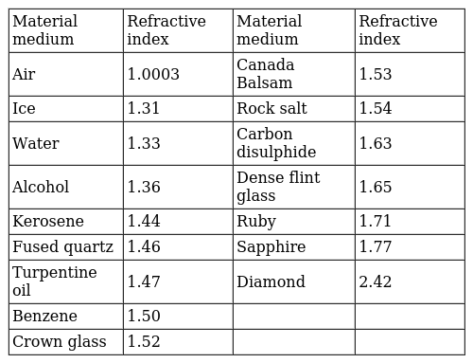 | [1]
41 | Give two precautions to obtain better results to determine the focal length of convex lens. | [1]
42 | Name the type of lens used to obtain  - an erect, enlarged and virtual image of an object,  - an erect, diminished and virtual image of an object. | [1]
43 | Find the power of a concave lens of focal length 2m? | [2]
44 | An object 3 cm high is placed 20 cm from convex lens of focal length 12 cm. Find the nature, position and height of the image. | [2]
45 | An object 6 cm in size is placed at 50 cm in front of a convex lens of focal length 30 cm. At what distance from the lens should a screen be placed in order to obtain a sharp image of the object? Find the nature and size of the image. Also draw labelled ray diagram to show the image formation in this case. | [2]
46 | - Draw a ray diagram to show the refraction of light through a glass slab and mark an angle of refraction and the lateral shift suffered by the ray of light while passing through the slab.  - If the refractive index of glass for light going from air to glass is 3/2, find the refractive index of air for light going from glass to air. | [2]
47 | Where should an object be placed in case of a convex lens to form an image of same size as of the object? Show with the help of ray diagram the position and the nature of the image formed. | [2]
48 | What happens after refraction, when:  - a ray of light parallel to the principal axis passes through a concave lens?  - a ray of light falls on a convex lens while passing through its principal focus?  - a ray of light passes through the optical centre of a convex lens? | [2]
49 | Draw ray diagram showing the image formation by a convex lens when an object is placed at twice the focal length of the lens. | [2]
50 | Complete the following diagram: 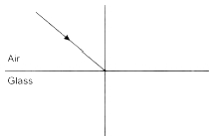 | [2]
51 | Draw ray diagram showing the image formation by a concave lens when an object is placed beyond twice the focal length of the lens. | [2]
52 | Draw ray diagram showing the image formation by a concave lens when an object is placed between focus and twice the focal length of the lens. | [2]
53 | A doctor has prescribed a corrective lens of power +1.5 D. Find the focal length of the lens. Is the prescribed lens diverging or converging? | [2]
54 | The diagram below shows the refracted CD through a concave lens. Complete the diagram by drawing the corresponding incident ray. 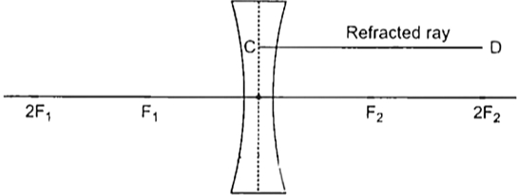 | [2]
55 | Light rays A and B fall on the component X and come out as C and D. 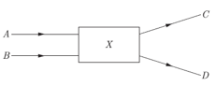  - Write the name of optical component.  - An object is placed at the radius of curvature of a concave spherical mirror. Where does image is formed by the mirror?  - What type of mirror is used in the construction of shaving glass? Why? | [2]
56 | Differentiate between a luminous and non - luminous source of light. | [2]
57 | Light enters from air to glass having refractive index 1.50. What is the speed of light in the glass? The speed of light in vacuum is$3×{10}^{8}ms^{−}1$ . | [2]
58 | Draw the following diagrams in your answer book and show the formation of the image of object AB by completing the ray diagrams. 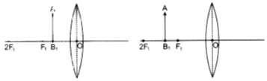 | [2]
59 | Define principal focus of a convex lens. | [2]
60 | Draw the ray diagram of ray entering a glass slab. Label angle of incidence, refraction and emergence. | [2]
61 | A real image,$\frac{4}{5}$ size of the object is formed 18 cm from a lens. Calculate focal length of the lens. | [2]
62 | If the image formed by a lens for all positions of an object placed in front of it is always erect and diminished, what is the nature of this lens? Draw a ray diagram to justify your answer. If the numerical value of the power of this lens is 10 D, what is its focal length in the Cartesian system? | [2]
63 | 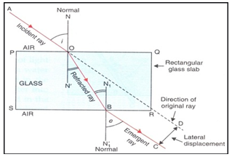  - Name the phenomenon.  - Write the laws of the following phenomenon that depicts in the above figure.  - Refractive index of diamond with respect to glass is 1.6. If the absolute refractive index of glass is 1.5. Find out the absolute refractive index of the diamond? | [2]
64 | An object is placed at a distance of 15 cm from a convex lens of focal length 20 cm. List four characteristics (nature, position, etc.) of the image formed by the lens. | [2]
65 | A concave lens has focal length of 15 cm. At what distance should the object from the lens be placed so that it forms an image at 10 cm from the lens? Also, find the magnification produced by the lens. | [2]
66 | - If the image formed by a lens is diminished in size and erect, for all positions of the object what type of lens is it?  - Name the point on the lens through which a ray of light passes undeviated.  - An object is placed perpendicular to the principal axis of a convex lens of focal length 20 cm. The distance of the object from lens is 30 cm. Find  - the position,  - the magnification and  - the nature of the image formed. | [2]
67 | Define the following terms in the context of a diverging mirror:  - Principal focus  - Focal length  Draw a labelled ray diagram to illustrate your answer. | [2]
68 | What is the power of lens ? What is its SI unit ? | [2]
69 | State the laws of refraction of light. Explain the term absolute refractive index of a medium and write an expression to relate it with the speed of light in vacuum. | [2]
70 | Draw ray diagram showing the image formation by a convex lens when an object is placed between focus and twice the focal length of the lens. | [2]
71 | Explain with the help of a ray diagram, why a pencil partly immersed in water appears to be bent at the water surface. | [2]
72 | The power of a lens is +4D. Find the focal length of this lens. An object is placed at a distance of 50 cm from the optical centre of this lens. State the nature and magnification of the image formed by the lens and also draw a ray diagram to justify your answer. | [2]
73 | What is the power of a combination of lenses? | [2]
74 | What is a rainbow? Draw a labelled diagram to show its formation. | [2]
75 | 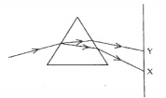  - What is the visible spectrum?  - Why is red used as the stopping light at traffic signals?  - Two triangular glass prisms are kept together connected through their rectangular side. A light beam is passed through one side of the combination. Will there be any dispersion? Justify your answer. | [2]

